Faculty of Electrical Engineering Department of Control Engineering and Robotics



Control Engineering and Systems (FEE-10024) Specialization Workshop

Subject 3.: Properties of electrical circuits

Student: Yusuf Vakkasoglu

Bialystok, 2020
Ph. D. Krzysztof Rogowski

1)



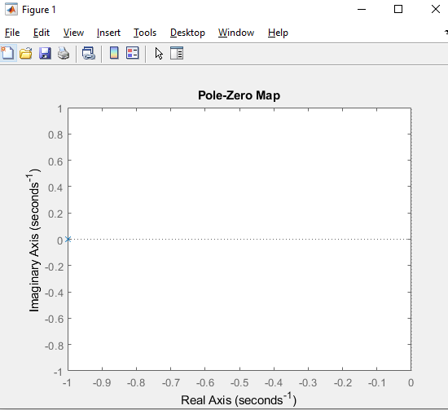

2-3)

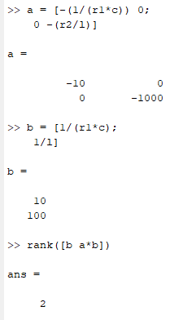

-----> rank[B AB] = n = 2. ----------------------- System is reachable.
-----> The controllability and reachability are equivalent properties for continuous-time systems.

4)

